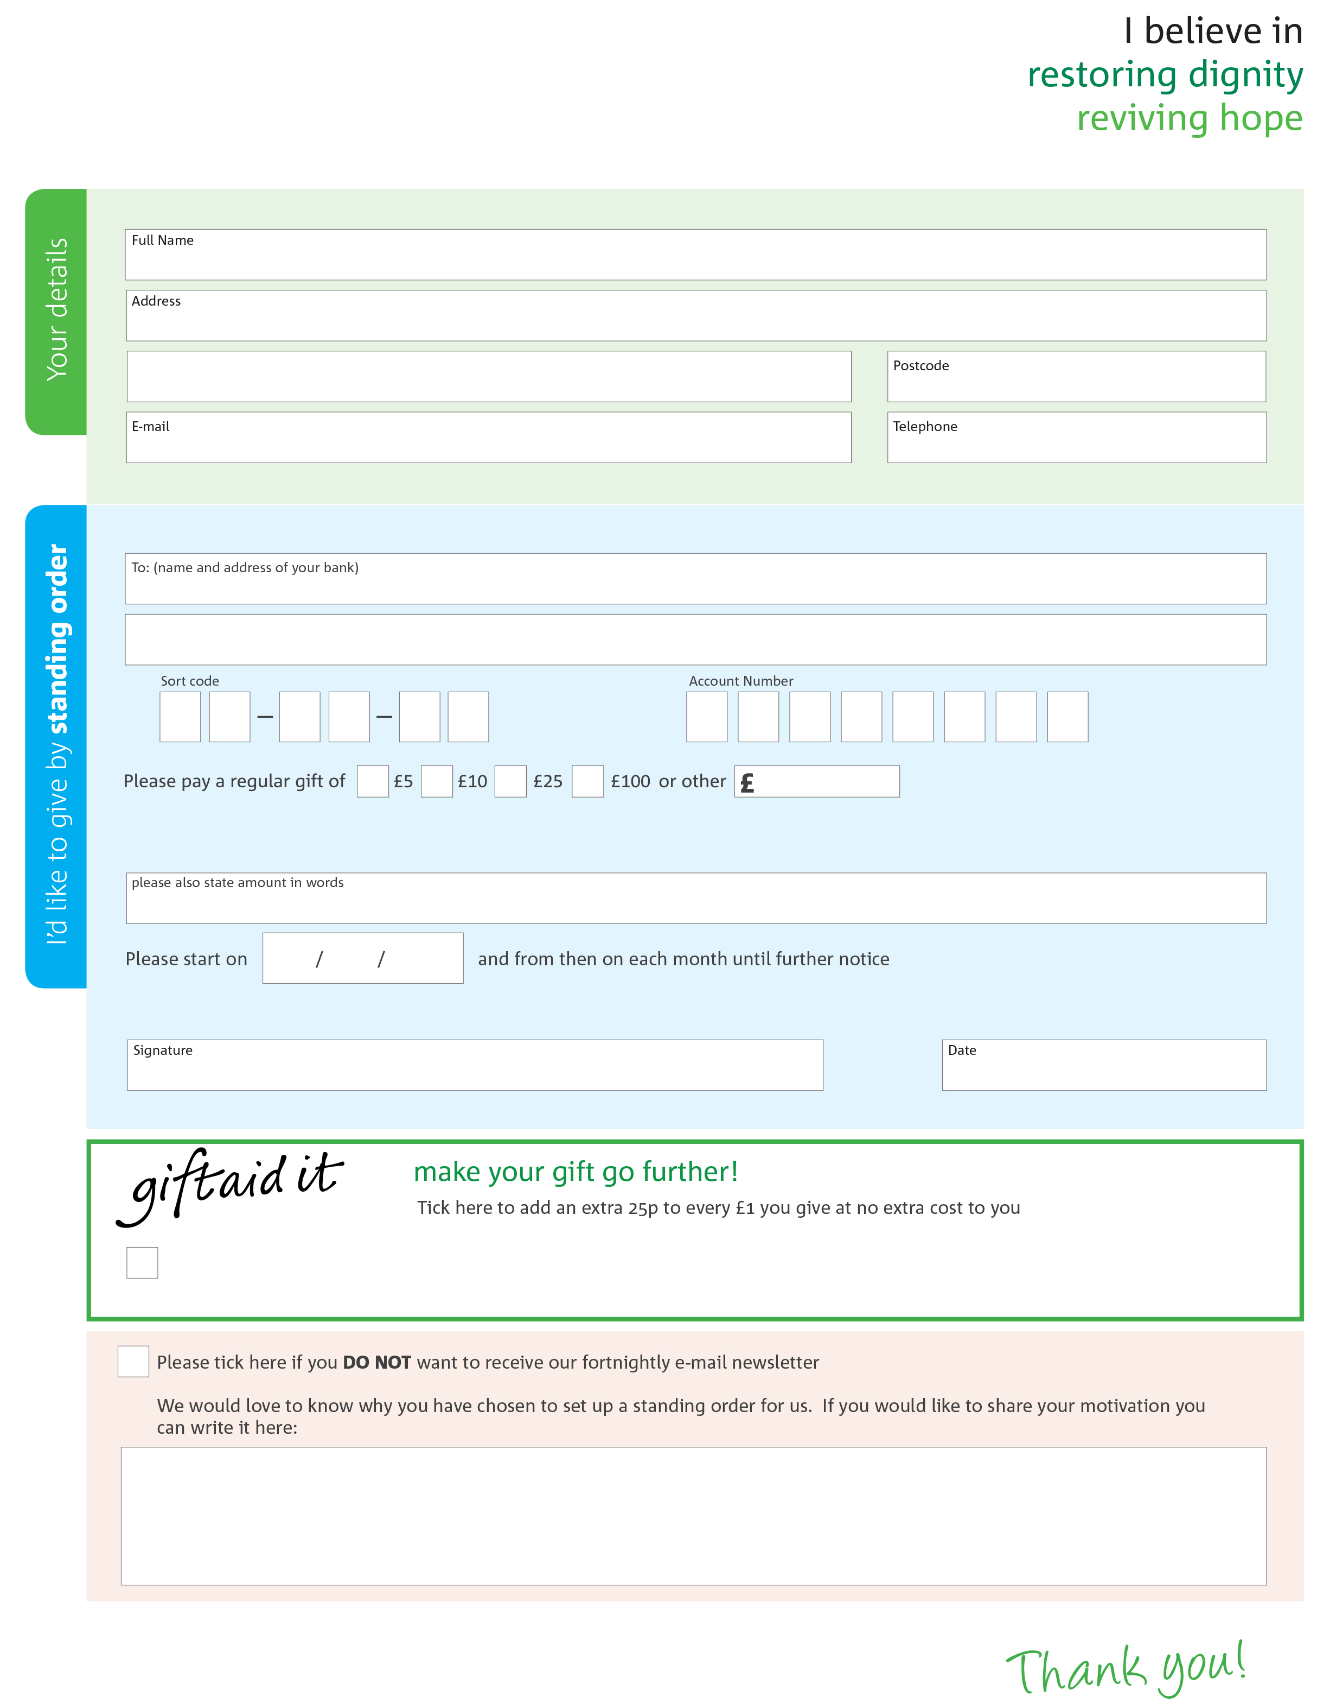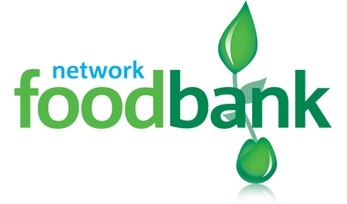­

Yes, I pay tax in the UK. Please treat all donations I make or have made to Kidderminster food bank for the past four years as gift aid donations until further notice.

I confirm I have paid or will pay an amount of Income Tax and/or Capital Gains Tax for each tax year (6 April to 5 April) that is at least equal to the amount of tax that all the charities or Community Amateur Sports Clubs (CASCs) that I donate to will reclaim on my gifts for that tax year. I understand that other taxes such as VAT and Council Tax do not qualify. I understand the charity will reclaim 25p of tax on every £1 that I give.

Please send your completed form to Kidderminster foodbank Unit 9 Swan Centre, Blackwell St.

Info:@Kidderminster.foodbank.org.uk

Bull Ring DY10 2AA

info@kidderminster.foodbank.org.uk

Kidderminster.foodbank.org.uk

Kidderminster foodbank’s bank details:

Address HSBC Bank

Sort code 40 26 08

Account number 31726064

Reg. Charity No: 1159223 | Reg. in England & Wales

This cancels any previous standing order instructions to kiddermister foodbank

To Kidderminster foodbank each month,