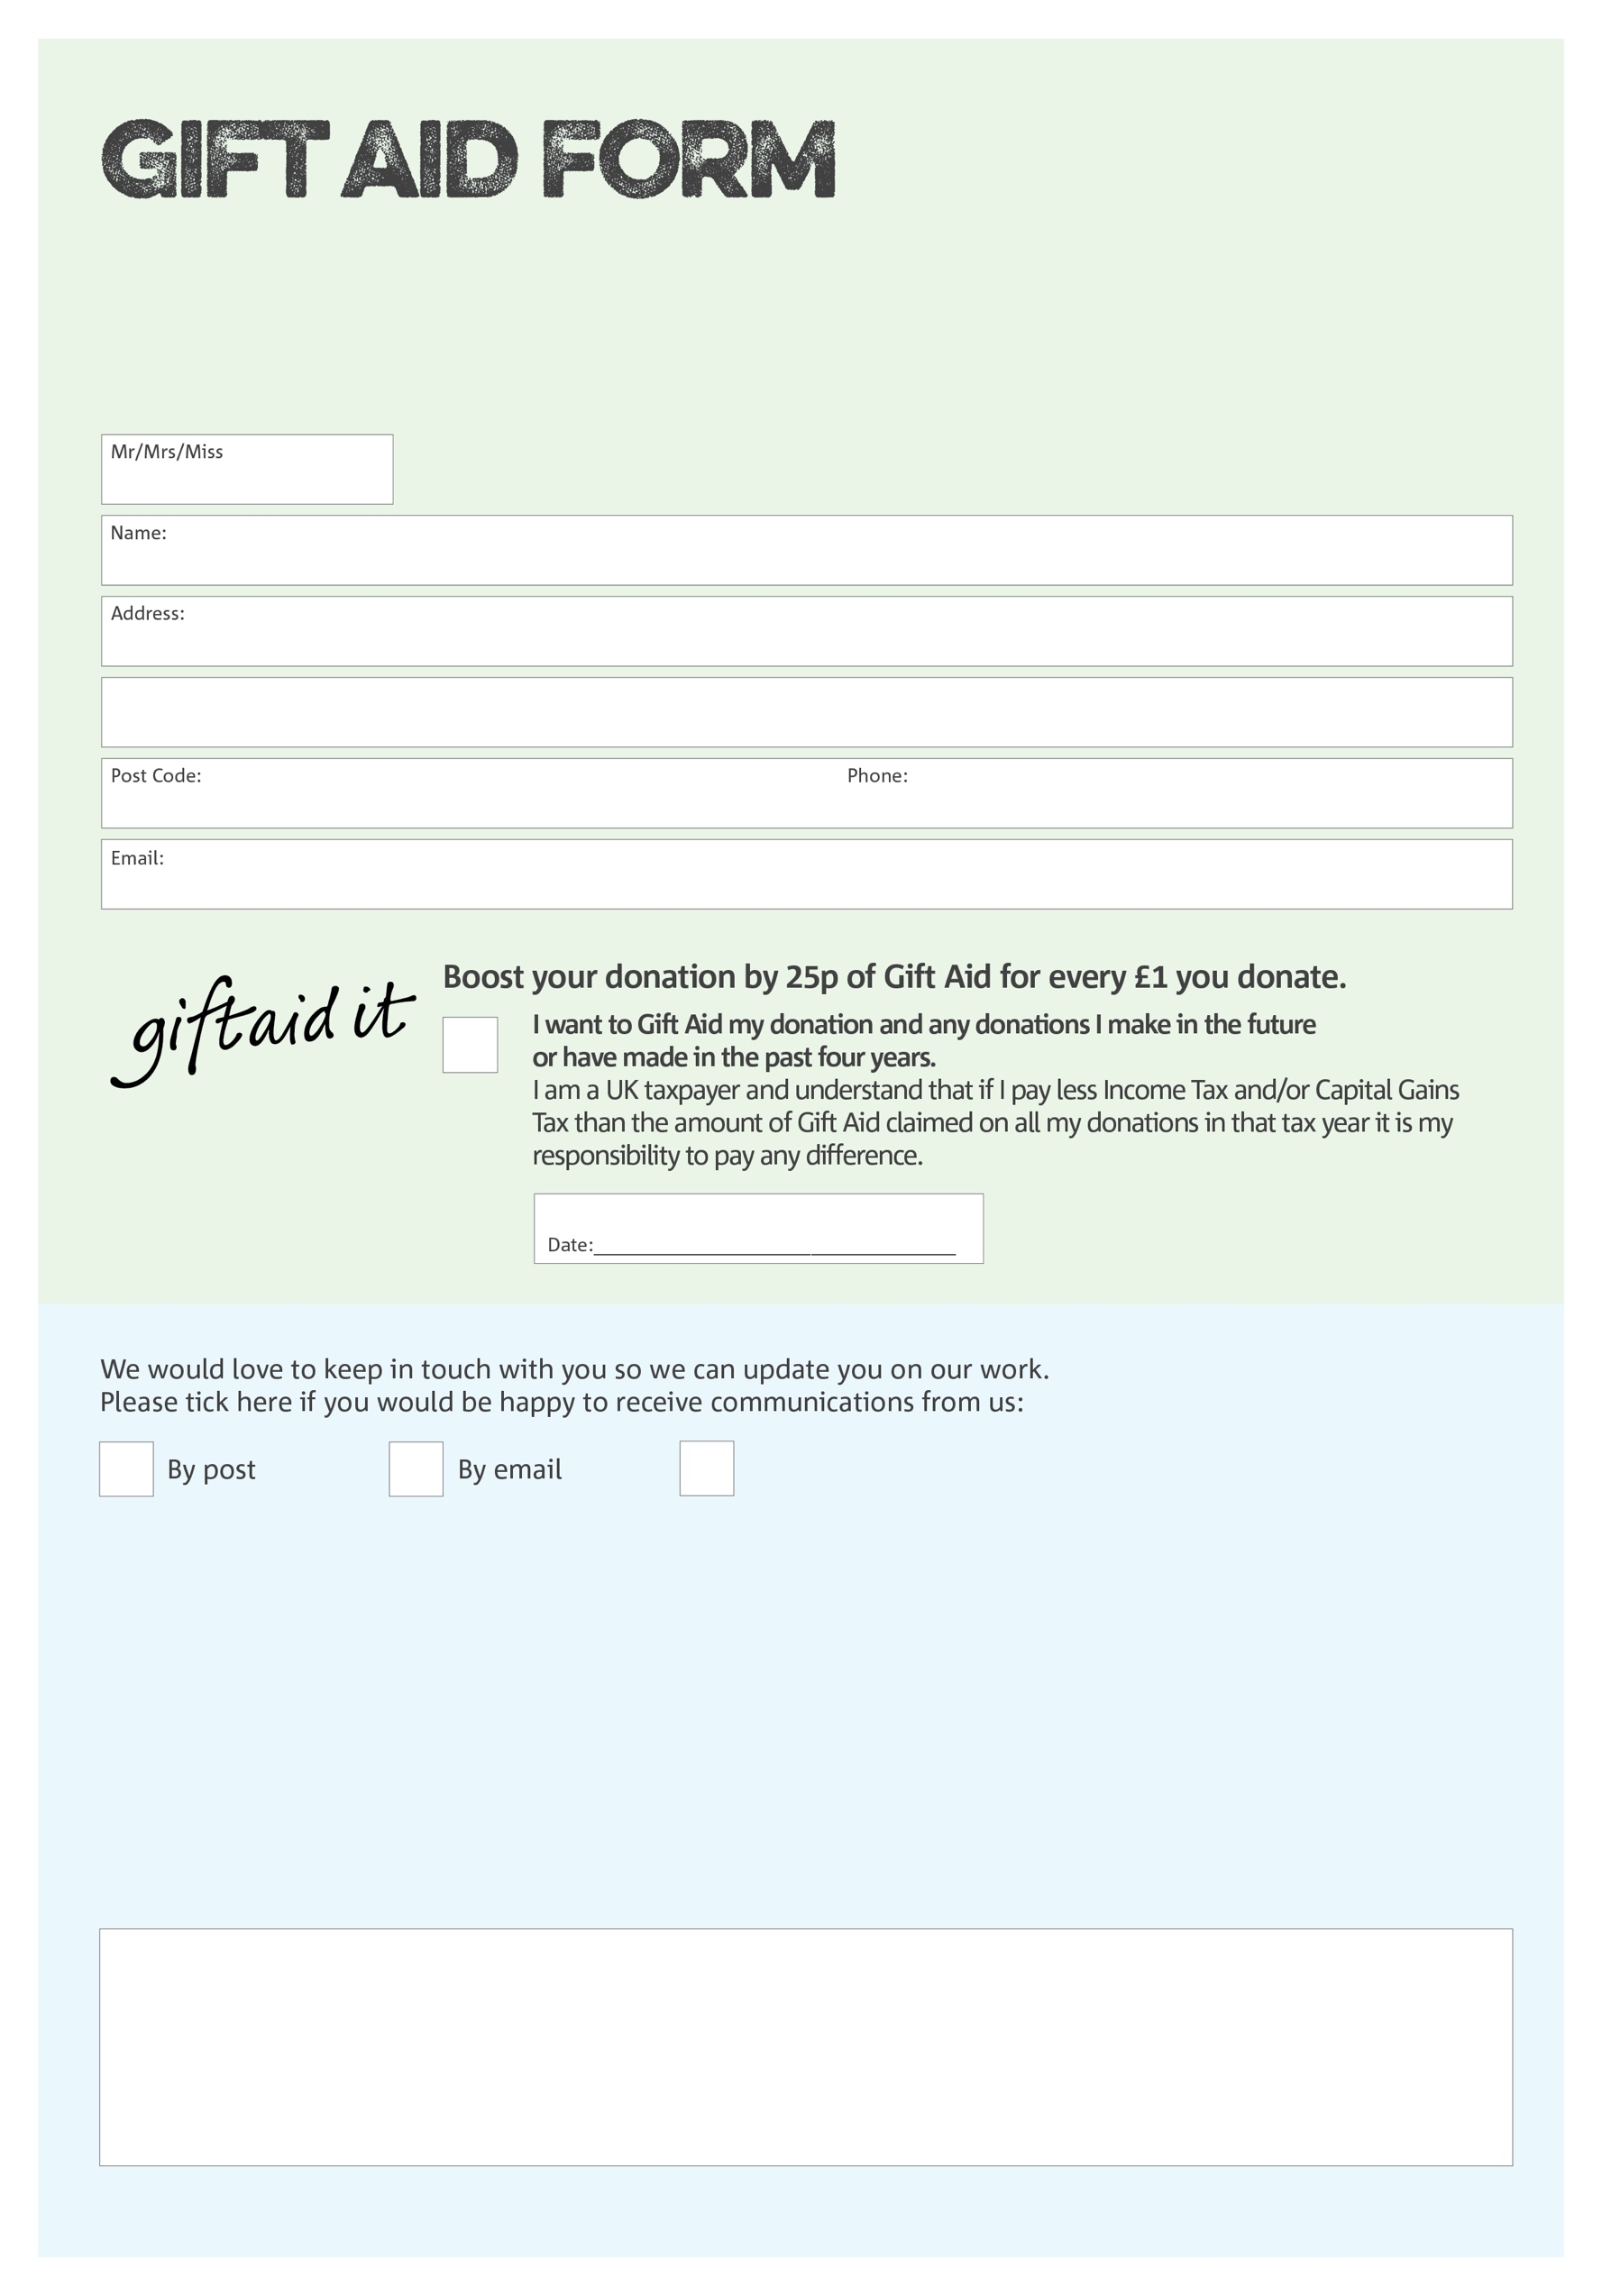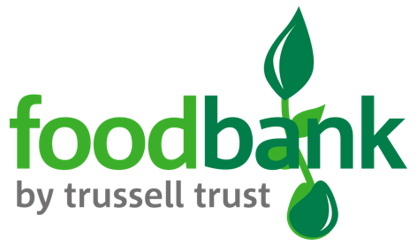

By filling in this form Kidderminster Foodbank will receive an extra 25p for every £1 you give at no extra cost to you. Thank you!

You can change your preferences any time by contacting us on 01562 746600 or emailing us at info@kidderminster.foodbank.org.uk

.foodbank.org.uk

I do not wish to receive future communications from XXXX Foodbank

**Data protection**

Kidderminster Foodbank is committed to protecting your privacy and will process your personal data in accordance with the Data Protection Act 1998. Kidderminster Foodbank collects information to keep in touch with you and supply you with information relating to our work. Kidderminster Foodbank will never sell or pass your details to anyone who isn’t directly working on our behalf.

We would love to know why you have chosen to donate to Kidderminster Foodbank. If you would like to share your motivation let us know below:

Charity Number 1159223 Registered in England